ERD

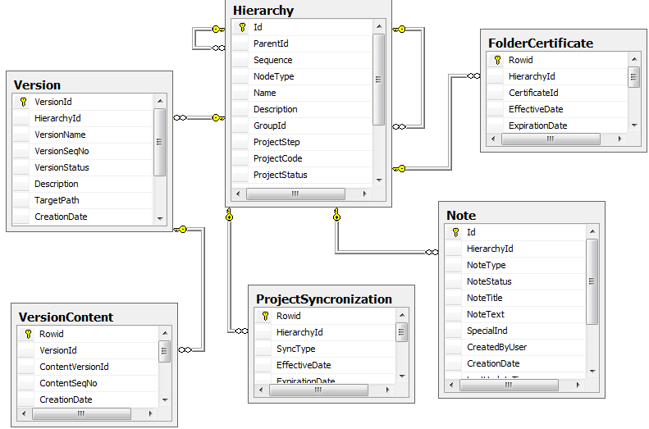

Create New Folder

1. Insert into Hierarchy, NodeType=’F’. GroupId, ProjectStep, ProjectCode, ProjectStatus are null.

Add content to folder

1. Update Hierarchy set NodeType=’P’
2. Insert into Version, HierarchyId from 1.
3. Insert into VersionContent, VersionId from 2

Create new project

1. Insert into Hierarchy, NodeType=’P’. GroupId is null.
2. Insert into Version, HierarchyId from 1.
3. Insert into VersionContent, VersionId from 2

Clone Project🡪Related, New group

1. Insert into Hierarchy, NodeType=’G’; ParentId, Sequence, GroupId, ProjectCode and ProjectStatus are null; Name and Description are populated with Group Name and Group Description from GUI; ProjectStep is populated with parent projects value if any.
2. Insert into Hierarchy, NodeType=’P’; GroupId from 1
3. Update Hierarchy set GroupId from 1 for parent project.
4. Update Version set HierarchyId=from 1 where HierarchyId=id of parent project (all versions will be linked to Group Node), set TargetPath to be identified with the group
5. Update Note set HierarchyId=from 1 where HierarchyId=id of parent project (all notes will be linked to Group Node Id)

Clone Project🡪Related, Existing group

Insert into Hierarchy, NodeType=’P’, GroupId of the parent project

Update related project 🡪all related projects

1. Version:

Update/insert into Version, HierarchyId= GroupId of the project

1. Note:

Update/Insert into Note, HierarchyId= GroupId of the project

1. Update Step

Update Hierarchy set ProjectStep where id= GroupId of the project

Update related project 🡪Separate project

1. Update Hierarchy set ProjectStep=ProjectStep of the Group (or from GUI if updated)
2. Update Hierarchy set GroupId null for separated project
3. Versions:

Insert into Version , HierachyId =Id of the selected project, TargetPath=default, all other attributes are selected from Version where HierarchyId=Id of the Group (or from GUI if updated).

1. Notes:

Insert into Note , HierachyId =Id of the selected project, all other attributes are selected from Note where HierarchyId=Id of the Group (or from GUI if updated).

Update related project🡪Separate project, only one project left in Group (🡪 no group anymore)

1. For selected project - 1, 2, 3, 4 from previous section
2. For the last project in the Group :

Update Hierarchy set GroupId null, ProjectStep is populated with Group value if any.

Update Version set HierarchyId to id of the project where HierarchyId=Id of the Group , set TargetPath to default (all Group versions are updated)

Update Note set HierarchyId to id of the project where HierarchyId=Id of the Group (all Group notes are updated).